**FOREST FIRE PREDICTION AND MANAGEMENT USING AI (ARTIFICIAL INTELLIGENCE), ML (MACHINE LEARNING) AND DEEP LEARNING TECHNIQUES**

**ABSTRACT**

Forest fires are one of the most devastating natural disasters, causing immense damage to ecosystems, wildlife, and human settlements. The early detection and effective management of forest fires can help mitigate their impact. This project aims to leverage Artificial Intelligence (AI), Machine Learning (ML), and Deep Learning (DL) techniques for forest fire prediction and management. By analyzing historical data, weather patterns, and environmental factors, the system predicts the likelihood of fire outbreaks, enabling timely intervention and resource allocation.

The project employs a combination of supervised and unsupervised machine learning models, including decision trees, random forests, and neural networks, to develop accurate prediction models. Deep learning techniques, such as Convolutional Neural Networks (CNNs), are used to process satellite images and other remote sensing data to identify fire-prone areas and monitor active fires in real-time. The system also incorporates data from IoT sensors placed in forests to track temperature, humidity, and smoke levels, which are critical indicators of potential fire risks.

The solution offers real-time alerts, early warnings, and fire risk assessments, which can be used by authorities to deploy firefighting resources effectively. Additionally, it provides actionable insights for forest management practices, helping to prevent large-scale fires by identifying vulnerable zones and suggesting preventive measures. This integrated approach of AI, ML, and DL for forest fire prediction and management aims to reduce the loss of life and property and preserve the natural environment for future generations.

**INTRODUCTION**

Forest fires are a growing global concern, impacting ecosystems, biodiversity, human lives, and property. Each year, millions of hectares of forests are destroyed by uncontrolled fires, leading to long-term environmental and economic consequences. Despite advances in firefighting techniques and prevention strategies, the unpredictability of forest fires poses a significant challenge for fire management agencies. Climate change, human activity, and the increased frequency of extreme weather events, such as droughts and heatwaves, are contributing to the rising occurrence of forest fires. The need for advanced and reliable tools for fire prediction and management has never been greater.

Traditional fire detection methods, such as manual patrols and aerial surveillance, are often insufficient to address the scale and speed at which fires spread. These methods are time-consuming, costly, and can sometimes lead to delayed responses in high-risk areas. Consequently, there is a pressing demand for automated and intelligent systems capable of predicting, detecting, and managing forest fires effectively. The advent of Artificial Intelligence (AI), Machine Learning (ML), and Deep Learning (DL) techniques presents an opportunity to revolutionize fire prediction and management systems, enabling faster and more accurate fire detection, risk assessment, and resource allocation.

The integration of AI, ML, and DL technologies into forest fire prediction and management can significantly enhance the accuracy and efficiency of fire detection and control. AI systems can process large volumes of data from various sources, including satellite imagery, weather conditions, topographical data, and real-time sensor readings. By analyzing these data points, AI can predict fire risks, detect early signs of fires, and generate actionable insights for forest management and emergency response.

Machine Learning models, particularly supervised learning algorithms such as decision trees, support vector machines (SVM), and random forests, can be trained on historical fire data to predict fire occurrences in specific regions. These models can consider multiple factors such as temperature, humidity, wind speed, vegetation density, and historical fire patterns to generate accurate fire risk maps and forecasts. Furthermore, unsupervised learning algorithms, such as clustering techniques, can identify hidden patterns and anomalies in fire-prone areas that may not be immediately apparent to human analysts.

Deep Learning techniques, especially Convolutional Neural Networks (CNNs), have shown great promise in analyzing satellite imagery and remote sensing data for fire detection. By training deep neural networks on vast datasets of images, CNNs can automatically identify fire outbreaks, smoke, and heat signatures with high accuracy. This capability allows for real-time fire detection and monitoring, enabling fire management authorities to respond quickly to emerging threats. In addition to image processing, deep learning can be used for predicting fire behavior, including spread rate and intensity, based on weather conditions and terrain features.

The combination of AI, ML, and DL not only enhances fire prediction accuracy but also optimizes fire management strategies. IoT-based sensors placed in forests can provide continuous monitoring of environmental parameters such as temperature, humidity, smoke concentration, and soil moisture levels. This real-time data, when integrated into AI-driven models, can enable early detection of fire hazards and trigger automated alerts for emergency responders. Moreover, predictive models can be used to simulate various fire scenarios, helping fire management agencies plan and allocate resources more effectively.

The overall goal of this project is to create an integrated AI-driven system that not only predicts forest fires but also aids in their management. By combining historical data, real-time monitoring, and advanced machine learning algorithms, the system can provide early warnings, assess fire risks, detect active fires, and optimize firefighting efforts. This project aims to contribute to reducing the frequency and severity of forest fires, mitigating the devastating consequences of these natural disasters, and providing forest management authorities with the tools they need to protect both human life and the environment.

Forest fires are a major environmental and societal challenge, posing significant risks to human lives, property, biodiversity, and the environment. The unpredictable nature of these fires, often accelerated by climate change, increasing temperatures, and human activities, has made forest fire management a critical issue for policymakers, emergency responders, and environmental scientists. Predicting forest fires in advance can help mitigate their destructive impacts. This project aims to develop a system using Artificial Intelligence (AI), Machine Learning (ML), and Deep Learning (DL) techniques to predict, detect, and manage forest fires in real-time. The goal is to create a robust and intelligent system capable of providing early warnings, risk assessments, and actionable insights for managing forest fires more efficiently.

**1.1 Motivation**

The motivation for this project stems from the growing need to address the devastating impact of forest fires on the global environment and society. Forest fires have caused widespread loss of life, destruction of property, and the degradation of ecosystems and biodiversity. The traditional methods of fire detection and management, such as aerial surveillance, manual patrols, and ground-based observations, are often inadequate in tackling the scale and speed at which fires can spread. These methods may result in delayed responses, escalating the severity of the fire and leading to significant damage.

Advances in AI, ML, and DL present an opportunity to automate and enhance fire detection and prediction. The integration of these technologies can lead to more accurate and timely fire forecasts, allowing authorities to deploy firefighting resources efficiently and effectively. Moreover, AI can help identify fire-prone areas, assess risks, and provide early warnings, which is crucial for forest management and disaster preparedness. The growing use of satellite imagery, IoT sensors, and other real-time monitoring technologies makes AI-driven solutions more feasible and valuable. Thus, the motivation for this project is to leverage AI, ML, and DL techniques to develop a comprehensive forest fire prediction and management system that can save lives, reduce environmental damage, and optimize firefighting efforts.

**1.2 Problem Definition**

Forest fires pose a significant problem due to their unpredictability and devastating consequences. Despite advances in firefighting techniques, predicting the occurrence and behavior of forest fires remains challenging. Fires can spread rapidly, often influenced by multiple factors such as weather conditions, terrain, vegetation, human activity, and lightning strikes. Traditional fire detection methods have limitations in terms of speed, coverage, and accuracy, which makes early detection and prevention difficult. Moreover, manual efforts to detect fires and assess fire risk areas are time-consuming and may not provide timely information for decision-makers.

Another significant problem is the difficulty in assessing fire behavior and predicting its future path. This is crucial for managing firefighting resources, as firefighters need to know the likely direction and intensity of the fire to allocate resources efficiently. Weather conditions, such as wind speed, humidity, and temperature, greatly influence fire behavior, making it hard to predict in real time without sophisticated tools.

Furthermore, the lack of real-time and dynamic data can hinder forest fire management efforts. Conventional methods may not integrate the vast amount of data available from satellite imagery, sensor networks, and weather data in a meaningful way. This makes it difficult to develop an accurate and timely prediction model for forest fires. Thus, the primary problem addressed by this project is the lack of an efficient, automated system that can predict forest fires accurately, provide early warnings, and assist in real-time management.

**1.3 Objective**

The main objective of this project is to develop a comprehensive and intelligent system that leverages AI, ML, and DL techniques to predict forest fires, detect them in real-time, and assist in their management. Specifically, the key objectives are:

1. **Prediction of Forest Fires:** The system will be trained using historical fire data and weather conditions to predict the likelihood of fire occurrences in different regions. By analyzing various environmental parameters, such as temperature, humidity, wind speed, vegetation, and historical fire trends, the system will generate accurate fire risk forecasts.
2. **Real-time Fire Detection:** The system will use real-time sensor data, satellite imagery, and other monitoring technologies to detect fires as soon as they occur. Deep learning models, particularly Convolutional Neural Networks (CNNs), will be utilized to process satellite images and detect fire outbreaks or smoke.
3. **Fire Behavior Simulation and Risk Assessment:** The system will simulate potential fire behavior based on weather data, topography, and other factors, providing insights into how a fire may spread. This can help authorities understand the potential impacts of the fire and allocate resources accordingly.
4. **Optimized Fire Management:** The system will provide actionable insights for managing forest fires more effectively. By analyzing real-time data and predicting fire risks, it will help fire management agencies optimize resource deployment, prioritize firefighting efforts, and minimize damage.
5. **Early Warning System:** The system will generate real-time alerts to notify authorities and local communities about potential fire outbreaks, enabling timely intervention and evacuation if necessary.
6. **Post-fire Recovery Assistance:** After the fire, the system will help evaluate the damage, identify affected areas, and provide data for forest recovery efforts and future prevention strategies.

By achieving these objectives, the project will contribute to reducing the frequency and severity of forest fires, minimizing their impact, and enhancing firefighting strategies through the integration of AI, ML, and DL technologies.

**1.4 Limitations of this Project**

While this project aims to provide a robust solution for forest fire prediction and management, several limitations need to be considered:

1. **Data Availability and Quality:** The effectiveness of AI and ML models is highly dependent on the quality and availability of data. In many regions, historical fire data may be sparse or incomplete, which can limit the model's ability to predict future fire occurrences accurately. Additionally, real-time sensor data may be missing or inconsistent in some areas, impacting the system's performance.
2. **Scalability and Coverage:** The project may face challenges in terms of scalability, especially when trying to apply the system to large and diverse geographic regions with varying weather conditions, vegetation types, and fire risks. Ensuring that the system can provide accurate predictions across different environments will require continuous improvement and adaptation.
3. **Real-time Processing:** Processing vast amounts of data in real-time for accurate fire detection and prediction is a significant challenge. Real-time processing requires high computational power, and delays in processing can reduce the effectiveness of the system, especially in fast-spreading fires.
4. **Model Complexity and Interpretability:** Deep learning models, while powerful, can be complex and difficult to interpret. Understanding why a model makes a certain prediction is crucial for trust and decision-making. The “black-box” nature of some AI and ML models can hinder their adoption, particularly in safety-critical applications such as fire management.
5. **Environmental Factors and External Influences:** The behavior of forest fires is influenced by numerous environmental factors, including weather, terrain, and human actions. While the system will account for many of these variables, unforeseen factors or extreme conditions may still affect the accuracy of the predictions.
6. **Integration with Existing Fire Management Systems:** Integrating AI-driven prediction systems with existing fire management practices and technologies could present challenges. Ensuring smooth integration and cooperation between traditional methods and new AI-driven approaches will be crucial for successful implementation.
7. **Cost and Resource Constraints:** Implementing a large-scale AI-based fire prediction system may require significant financial resources and infrastructure investment. This includes data collection, sensor installation, system development, and computational power for real-time analysis. The cost-effectiveness of such systems will be a consideration for governments and organizations.
8. **Legal and Ethical Considerations:** The use of AI and satellite imagery for fire prediction raises concerns about privacy, data security, and regulatory compliance. Ensuring that the system adheres to legal and ethical standards will be essential, especially when using data from sensors and satellite imagery that may capture private property or sensitive areas.

**LITERATURE SURVEY**

The literature survey for the project on "Forest Fire Prediction and Management using AI, ML, and Deep Learning Techniques" serves as a comprehensive review of the existing systems, technologies, and methodologies used in forest fire prediction and management. This survey aims to explore the current state of research, highlight the limitations of existing approaches, and identify areas where advanced technologies such as Artificial Intelligence (AI), Machine Learning (ML), and Deep Learning (DL) can offer improvements.

**2.1 Introduction**

Forest fires are a growing concern across the globe due to their widespread environmental, economic, and societal impacts. Over the years, there have been numerous attempts to develop systems and methods for predicting, detecting, and managing forest fires. Early detection of forest fires is critical for mitigating the damage they cause, and various approaches, such as statistical models, remote sensing, and sensor networks, have been used to address this challenge. However, despite advancements in technology, forest fire prediction remains a difficult and complex problem, often influenced by a variety of factors, including weather patterns, terrain, vegetation types, and human activities.

In recent years, AI, ML, and DL have shown promise in enhancing the accuracy and effectiveness of fire prediction systems. These technologies offer the potential to automate fire detection, predict fire behavior, and optimize resource management. By processing vast amounts of data from multiple sources, including satellite imagery, weather data, and sensor networks, AI-powered systems can provide real-time insights and early warnings, improving the ability to respond to fires before they escalate.

This section reviews existing forest fire prediction and management systems, the limitations of traditional approaches, and how AI and ML can improve the prediction and management of forest fires.

**2.2 Existing System**

Several traditional and modern systems for forest fire prediction and management have been developed and implemented in various regions of the world. These systems employ a variety of approaches, such as statistical models, remote sensing, and sensor networks. Some of the most common methods and systems are as follows:

1. **Statistical and Empirical Models:** One of the earliest approaches to forest fire prediction involved statistical and empirical models that used historical fire data, weather conditions, and other environmental variables to predict fire occurrences. These models relied on statistical correlations between weather factors (temperature, humidity, wind speed) and fire incidents to generate fire risk predictions. One example is the **Fire Weather Index (FWI)**, which uses weather parameters to assess fire danger. However, these models often lack accuracy, especially in regions with complex topography and changing climate patterns.
2. **Remote Sensing and Satellite Imagery:** Remote sensing technologies have become a vital tool for forest fire detection. Satellite-based systems, such as **MODIS (Moderate Resolution Imaging Spectroradiometer)** and **Landsat**, have been widely used to monitor forest fires. These systems detect heat signatures, smoke plumes, and other indicators of fire activity in real-time. Through the analysis of satellite imagery, fire detection can be achieved using algorithms that identify temperature anomalies. However, these systems still rely heavily on external factors such as cloud cover and satellite revisit times, which can hinder real-time detection and delay fire response.
3. **Sensor Networks and IoT-Based Systems:** In recent years, the use of sensor networks and the Internet of Things (IoT) has grown in popularity for monitoring environmental conditions in forested areas. IoT sensors can be deployed in forests to monitor temperature, humidity, smoke levels, and soil moisture. These sensors provide continuous data, which can be used to assess the likelihood of fire outbreaks. Some projects have integrated these sensors with communication systems to provide real-time alerts. However, the installation and maintenance of such networks can be costly and challenging, especially in remote forest areas.
4. **Geospatial Information Systems (GIS):** GIS-based fire risk mapping has also been used to predict areas prone to wildfires. These systems combine spatial data (such as vegetation, terrain, and historical fire locations) with environmental factors (weather, temperature, etc.) to produce fire risk maps. These maps help fire management authorities prioritize areas for fire prevention and intervention. However, while GIS can assist in fire risk assessments, it does not offer real-time fire detection or prediction capabilities, limiting its utility in actual fire management.
5. **Artificial Intelligence and Machine Learning:** AI and ML-based systems have emerged as powerful tools for forest fire prediction. Early studies have explored the use of machine learning algorithms, such as decision trees, random forests, and support vector machines, for classifying areas based on fire risk. These systems are trained using historical fire data and environmental variables to generate predictions for fire occurrence. AI and ML models are often more accurate than traditional models because they can learn from large datasets and account for complex, nonlinear relationships between variables.

**Deep Learning** techniques, such as Convolutional Neural Networks (CNNs), have been applied to satellite imagery and remote sensing data for fire detection. CNNs are capable of identifying heat signatures and smoke patterns with high accuracy. Deep learning models can also predict fire behavior by considering environmental and meteorological factors.

**2.3 Disadvantages**

Despite the advancements in fire prediction and detection technologies, there are several challenges and limitations to the existing systems:

1. **Data Quality and Availability:** One of the major limitations of existing systems is the availability and quality of data. Many traditional models rely on historical fire data, which may be incomplete or biased. Additionally, real-time sensor data can sometimes be inaccurate or missing, particularly in remote areas. Inconsistent data quality can lead to unreliable predictions.
2. **Limited Real-time Detection:** While satellite imagery and sensor networks can provide valuable insights into fire occurrences, these systems often suffer from delays due to satellite revisit times, cloud cover, and sensor data transmission. These delays can hinder the timely detection of fires, which is critical for effective firefighting response.
3. **Limited Prediction Accuracy:** Traditional fire prediction models based on statistical methods often have limited accuracy, especially in regions with diverse terrain and changing climate conditions. These models are unable to account for the dynamic nature of forest fires, which are influenced by a variety of factors such as terrain, wind speed, and human activity.
4. **High Cost of Deployment:** Sensor networks and IoT-based systems can be expensive to deploy and maintain, especially in remote forested areas. Moreover, these systems require continuous monitoring, which can increase operational costs.
5. **Complexity of Integration:** Integrating different technologies, such as remote sensing, sensor networks, and AI, into a cohesive fire prediction and management system can be complex. There are often challenges in combining diverse data sources and ensuring that the system works efficiently across different platforms.

**2.4 Proposed System**

The proposed system aims to address the limitations of existing approaches by leveraging AI, ML, and DL techniques to develop a comprehensive fire prediction and management system. Key features of the proposed system include:

1. **AI-Driven Prediction Models:** By employing machine learning algorithms such as decision trees, random forests, and support vector machines, the system can predict fire risks based on environmental factors, weather conditions, and historical fire data. The models will learn patterns and improve over time, resulting in more accurate fire risk forecasts.
2. **Deep Learning for Fire Detection:** The use of deep learning models, particularly Convolutional Neural Networks (CNNs), will enable the system to analyze satellite imagery and remote sensing data to detect fires in real time. These models will be trained to recognize heat signatures and smoke patterns with high accuracy, enabling rapid fire detection.
3. **Real-time Sensor Integration:** The system will integrate data from IoT sensors deployed in forests to monitor temperature, humidity, smoke levels, and other relevant environmental parameters. The real-time data will be used to continuously assess fire risk and trigger automated alerts when fire conditions are detected.
4. **Fire Behavior Prediction:** The system will use advanced machine learning algorithms to predict fire behavior by considering environmental factors such as wind speed, temperature, humidity, and terrain. This will allow firefighting agencies to better understand the potential spread of a fire and deploy resources more efficiently.
5. **Early Warning and Resource Optimization:** The system will provide early warnings about potential fire outbreaks, giving authorities ample time to prepare. Additionally, the system will assist in resource optimization by generating fire risk maps, identifying vulnerable areas, and prioritizing firefighting efforts.
6. **Cloud-based Infrastructure:** The system will be deployed on a cloud-based infrastructure to enable real-time data processing and analysis. Cloud computing will facilitate the scalability of the system, ensuring that it can handle large datasets from satellite imagery, sensor networks, and other sources.

**2.5 Conclusion**

This literature survey highlights the progress made in forest fire prediction and management, focusing on both traditional and modern approaches. While existing systems have provided valuable insights and tools for fire detection and prevention, they are often limited by factors such as data availability, real-time processing, prediction accuracy, and scalability.

The proposed AI, ML, and DL-based system aims to overcome these limitations by providing accurate, real-time predictions and early fire detection. By integrating diverse data sources, including satellite imagery, IoT sensors, and historical fire data, the proposed system offers a comprehensive solution for forest fire prediction and management. It has the potential to significantly improve the effectiveness of firefighting efforts, optimize resource allocation, and mitigate the devastating impact of forest fires.

**SYSTEM ANALYSIS**

**3 Software environment**

The successful execution of the cyberbullying prediction project relies on a robust set of tools and technologies that facilitate data collection, analysis, model building, and evaluation. This section outlines the key programming languages, libraries, and platforms used in the project.

**3.1 Introduction to Python**

Python is an interpreted, high-level, general-purpose programming language. Created by Guido van Rossum and first released in 1991, Python's design philosophy emphasizes code readability with its notable use of significant whitespace. Its language constructs and object-oriented approach aim to help programmers write clear, logical code for small and large-scale projects. Python is dynamically typed and garbage-collected. It supports multiple programming paradigms, including structured (particularly, procedural), object-oriented, and functional programming. Python is often described as a "batteries included" language due to its comprehensive standard library. Python was conceived in the late 1980s as a successor to the ABC language. Python 2.0, released in 2000, introduced features like list comprehensions and a garbage collection system capable of collecting reference cycles.

Python 3.0, released in 2008, was a major revision of the language that is not completely backward-compatible, and much Python 2 code does not run unmodified on Python 3. The Python 2 language, i.e., Python 2.7.x, was officially discontinued on 1 January 2020 (first planned for 2015) after which security patches and other improvements will not be released for it.[32][33] With Python 2's end-of-life, only Python 3.5.x and later are supported. Python interpreters are available for many operating systems. A global community of programmers develops and maintains CPython, an open-source implementation. A non-profit organization, the Python Software Foundation, manages and directs resources for Python and CPython development.

**SYNTAX AND SEMANTICS**

Python is meant to be an easily readable language. Its formatting is visually uncluttered, and it often uses English keywords where other languages use punctuation.

Unlike many other languages, it does not use curly brackets to delimit blocks, and semicolons after statements are optional. It has fewer syntactic exceptions and special cases than C or Pascal.

**INDENTION**

Main article: Python syntax and semantics § Indentation

Python uses whitespace indentation, rather than curly brackets or keywords, to delimit blocks. An increase in indentation comes after certain statements; a decrease in indentation signifies the end of the current block. Thus, the program's visual structure accurately represents the program's semantic structure. This feature is sometimes termed the off-side rule, which some other languages share, but in most languages, indentation doesn't have any semantic meaning.

**STATEMENTS AND CONTROL FLOW**

Python's statements include (among others):

The assignment statement (token '=', the equals sign). This operates differently than in traditional imperative programming languages, and this fundamental mechanism (including the nature of Python's version of variables) illuminates many other features of the language. Assignment in C, e.g., x = 2, translates to "typed variable name x receives a copy of numeric value 2". The (right-hand) value is copied into an allocated storage location for which the (left-hand) variable name is the symbolic address. The memory allocated to the variable is large enough (potentially quite large) for the declared type. In the simplest case of Python assignment, using the same example, x = 2, translates to "(generic) name x receives a reference to a separate, dynamically allocated object of numeric (int) type of value 2." This is termed binding the name to the object.

Since the name's storage location doesn't contain the indicated value, it is improper to call it a variable. Names may be subsequently rebound at any time to objects of greatly varying types, including strings, procedures, complex objects with data and methods, etc. Successive assignments of a common value to multiple names, e.g., x = 2; y = 2; z = 2 result in allocating storage to (at most) three names and one numeric object, to which all three names are bound.

Since a name is a generic reference holder it is unreasonable to associate a fixed data type with it. However, at a given time a name will be bound to some object, which will have a type; thus there is dynamic typing.

* The if statement, which conditionally executes a block of code, along with else and elif (a contraction of else-if).
* The for statement, which iterates over an iterable object, capturing each element to a local variable for use by the attached block.
* The while statement, which executes a block of code as long as its condition is true.
* The try statement, which allows exceptions raised in its attached code block to be caught and handled by except clauses; it also ensures that clean-up code in a finally block will always be run regardless of how the block exits.
* The raise statement, used to raise a specified exception or re-raise a caught exception.
* The class statement, which executes a block of code and attaches its local namespace to a class, for use in object-oriented programming.
* The def statement, which defines a function or method.
* The with statement, from Python 2.5 released in September 2006, which encloses a code block within a context manager (for example, acquiring a lock before the block of code is run and releasing the lock afterwards, or opening a file and then closing it), allowing Resource Acquisition Is Initialization (RAII)-like behaviour and replaces a common try/finally idiom.
* The break statement, exits from the loop.
* The continue statement, skips this iteration and continues with the next item.
* The pass statement, which serves as a NOP. It is syntactically needed to create an empty code block.
* The assert statement, used during debugging to check for conditions that ought to apply.
* The yield statement, which returns a value from a generator function. From Python 2.5, yield is also an operator. This form is used to implement coroutines.

The import statement, which is used to import modules whose functions or variables can be used in the current program. There are three ways of using import: import <module name> [as <alias>] or from <module name> import * or from <module name> import <definition 1> [as <alias 1>], <definition 2> [as <alias 2>],

The print statement was changed to the print () function in Python 3.

Python does not support tail call optimization or first-class continuations, and, according to Guido van Rossum, it never will. However, better support for coroutine-like functionality is provided in 2.5, by extending Python's generators. Before 2.5, generators were lazy iterators; information was passed unidirectionally out of the generator. From Python 2.5, it is possible to pass information back into a generator function, and from Python 3.3, the information can be passed through multiple stack levels.

**EXPRESSIONS**

Some Python expressions are similar to languages such as C and Java, while some are not:

Addition, subtraction, and multiplication are the same, but the behaviour of division differs. There are two types of divisions in Python. They are floor division (or integer division) // and floating point/division. Python also added the ** operator for exponentiation.

From Python 3.5, the new @ infix operator was introduced. It is intended to be used by libraries such as NumPy for matrix multiplication.

From Python 3.8, the syntax: =, called the 'walrus operator' was introduced. It assigns values to variables as part of a larger expression.

In Python, == compares by value, versus Java, which compares numeri’s by value and objects by reference. (Value comparisons in Java on objects can be performed with the equals () method.) Python's is operator may be used to compare object identities (comparison by reference). In Python, comparisons may be chained, for example a <= b <= c.

Python uses the words and, or, not for its Boolean operators rather than the symbolic &&, ||, ! used in Java and C.

Python has a type of expression termed a list comprehension. Python 2.4 extended list comprehensions into a more general expression termed a generator expression.

Anonymous functions are implemented using lambda expressions; however, these are limited in that the body can only be one expression.

Conditional expressions in Python are written as x if c else y (different in order of operands from the c? x : y operator common to many other languages).

Python makes a distinction between lists and tuples. Lists are written as [1, 2, 3], are mutable, and cannot be used as the keys of dictionaries (dictionary keys must be immutable in Python). Tuples are written as (1, 2, 3), are immutable and thus can be used as the keys of dictionaries, provided all elements of the tuple are immutable. The + operator can be used to concatenate two tuples, which does not directly modify their contents, but rather produces a new tuple containing the elements of both provided tuples. Thus, given the variable t initially equal to (1, 2, 3), executing t = t + (4, 5) first evaluates t + (4, 5), which yields (1, 2, 3, 4, 5), which is then assigned back to t, thereby effectively "modifying the contents" of t, while conforming to the immutable nature of tuple objects. Parentheses are optional for tuples in unambiguous contexts.

Python features sequence unpacking wherein multiple expressions, each evaluating to anything that can be assigned to (a variable, a writable property, etc.), are associated in the identical manner to that forming tuple literals and, as a whole, are put on the left-hand side of the equal sign in an assignment statement. The statement expects an iterable object on the right-hand side of the equal sign that produces the same number of values as the provided writable expressions when iterated through, and will iterate through it, assigning each of the produced values to the corresponding expression on the left.

Python has a "string format" operator %. These functions analogous to printf format strings in C, e.g. "spam=%s eggs=%d" % ("blah", 2) evaluates to "spam=blah eggs=2".

In Python 3 and 2.6+, this was supplemented by the format () method of the str class, e.g. "spam={0} eggs={1}". format("blah", 2). Python 3.6 added "f-strings": blah = "blah"; eggs = 2; f'spam={blah} eggs={eggs}'.

**Python has various kinds of string literals**

Strings delimited by single or double quote marks. Unlike in Unix shells, Perl and Perl-influenced languages, single quote marks and double quote marks function identically. Both kinds of string use the backslash (\) as an escape character. String interpolation became available in Python 3.6 as "formatted string literals".

Triple-quoted strings, which begin and end with a series of three single or double quote marks. They may span multiple lines and function like here documents in shells, Perl and Ruby.

Raw string varieties, denoted by prefixing the string literal with an r. Escape sequences are not interpreted; hence raw strings are useful where literal backslashes are common, such as regular expressions and Windows-style paths. Compare "@-quoting" in C#.

Python has array index and array slicing expressions on lists, denoted as a[key], a[start: stop] or a[start:stop:step]. Indexes are zero-based, and negative indexes are relative to the end. Slices take elements from the start index up to, but not including, the stop index. The third slice parameter, called step or stride, allows elements to be skipped and reversed. Slice indexes may be omitted, for example a[:] returns a copy of the entire list. Each element of a slice is a shallow copy.

In Python, a distinction between expressions and statements is rigidly enforced, in contrast to languages such as Common Lisp, Scheme, or Ruby. This leads to duplicating some functionality. For example:

List comprehensions vs. for-loops

Conditional expressions vs. if blocks

The eval() vs. exec() built-in functions (in Python 2, exec is a statement); the former is for expressions, the latter is for statements.

Statements cannot be a part of an expression, so list and other comprehensions or lambda expressions, all being expressions, cannot contain statements. A particular case of this is that an assignment statement such as a = 1 cannot form part of the conditional expression of a conditional statement. This has the advantage of avoiding a classic C error of mistaking an assignment operator = for an equality operator == in conditions: if (c = 1) { ... } is syntactically valid (but probably unintended) C code but if c = 1: ... causes a syntax error in Python.

**METHODS**

Methods on objects are functions attached to the object's class; the syntax instance. method(argument) is, for normal methods and functions, syntactic sugar for Class. method(instance, argument). Python methods have an explicit self parameter to access instance data, in contrast to the implicit self (or this) in some other object-oriented programming languages (e.g., C++, Java, Objective-C, or Ruby).

**APPLICATIONS OF PYTHON**

As mentioned before, Python is one of the most widely used language over the web. I'm going to list few of them here:

**Easy-to-learn** − Python has few keywords, simple structure, and a clearly defined syntax. This allows the student to pick up the language quickly.

**Easy-to-read** − Python code is more clearly defined and visible to the eyes.

**Easy-to-maintain** − Python's source code is fairly easy-to-maintain.

**A broad standard library** − Python's bulk of the library is very portable and cross-platform compatible on UNIX, Windows, and Macintosh.

**Interactive Mode** − Python has support for an interactive mode which allows interactive testing and debugging of snippets of code.

**Portable** − Python can run on a wide variety of hardware platforms and has the same interface on all platforms.

**Extendable** − You can add low-level modules to the Python interpreter. These modules enable programmers to add to or customize their tools to be more efficient.

**Databases** − Python provides interfaces to all major commercial databases.

**GUI Programming** − Python supports GUI applications that can be created and ported to many system calls, libraries and windows systems, such as Windows MFC, Macintosh, and the X Window system of Unix.

**Scalable** − Python provides a better structure and support for large programs than shell scripting.

**Python OOPs Concepts**

Like other general-purpose programming languages, Python is also an object-oriented language since its beginning. It allows us to develop applications using an Object-Oriented approach. In [Python](https://www.javatpoint.com/python-tutorial), we can easily create and use classes and objects.

An object-oriented paradigm is to design the program using classes and objects. The object is related to real-word entities such as book, house, pencil, etc. The oops concept focuses on writing the reusable code. It is a widespread technique to solve the problem by creating objects.

Major principles of object-oriented programming system are given below.

* Class
* Object
* Method
* Inheritance
* Polymorphism
* Data Abstraction
* Encapsulation

Class

**The class can be defined as a collection of objects. It is a logical entity that has some specific attributes and methods. For example: if you have an employee class, then it should contain an attribute and method, i.e. an email id, name, age, salary, etc.**

Syntax

**class** ClassName:

        <statement-1>

        .

        .

        <statement-N>

Object

**The object is an entity that has state and behavior. It may be any real-world object like the mouse, keyboard, chair, table, pen, etc.**

**Everything in Python is an object, and almost everything has attributes and methods. All functions have a built-in attribute __doc__, which returns the docstring defined in the function source code.**

**When we define a class, it needs to create an object to allocate the memory. Consider the following example.**

Method

**The method is a function that is associated with an object. In Python, a method is not unique to class instances. Any object type can have methods.**

Inheritance

**Inheritance is the most important aspect of object-oriented programming, which simulates the real-world concept of inheritance. It specifies that the child object acquires all the properties and behaviors of the parent object.**

**By using inheritance, we can create a class which uses all the properties and behavior of another class. The new class is known as a derived class or child class, and the one whose properties are acquired is known as a base class or parent class.**

**it provides the re-usability of the code.**

**Polymorphism**

Polymorphism contains two words "poly" and "morphs". Poly means many, and morph means shape. By polymorphism, we understand that one task can be performed in different ways. For example - you have a class animal, and all animals speak. But they speak differently. Here, the "speak" behavior is polymorphic in a sense and depends on the animal. So, the abstract "animal" concept does not actually "speak", but specific animals (like dogs and cats) have a concrete implementation of the action "speak".

**Encapsulation**

Encapsulation is also an essential aspect of object-oriented programming. It is used to restrict access to methods and variables. In encapsulation, code and data are wrapped together within a single unit from being modified by accident.

**Data Abstraction**

Data abstraction and encapsulation both are often used as synonyms. Both are nearly synonyms because data abstraction is achieved through encapsulation.

Abstraction is used to hide internal details and show only functionalities. Abstracting something means to give names to things so that the name captures the core of what a function or a whole program does.

**Python Class and Objects**

We have already discussed in previous tutorial, a class is a virtual entity and can be seen as a blueprint of an object. The class came into existence when it instantiated. Let's understand it by an example.

Suppose a class is a prototype of a building. A building contains all the details about the floor, rooms, doors, windows, etc. we can make as many buildings as we want, based on these details. Hence, the building can be seen as a class, and we can create as many objects of this class.

On the other hand, the object is the instance of a class. The process of creating an object can be called instantiation.

In this section of the tutorial, we will discuss creating classes and objects in Python. We will also discuss how a class attribute is accessed by using the object.

**Creating classes in Python**

In Python, a class can be created by using the keyword class, followed by the class name. The syntax to create a class is given below.

Syntax

**class** ClassName:

 #statement_suite

In Python, we must notice that each class is associated with a documentation string which can be accessed by using **<class-name>.__doc__.** A class contains a statement suite including fields, constructor, function, etc. definition.

Consider the following example to create a class **Employee** which contains two fields as Employee id, and name.

The class also contains a function **display(),** which is used to display the information of the **Employee.**

Here, the **self**is used as a reference variable, which refers to the current class object. It is always the first argument in the function definition. However, using **self** is optional in the function call.

**The self-parameter**

The self-parameter refers to the current instance of the class and accesses the class variables. We can use anything instead of self, but it must be the first parameter of any function which belongs to the class.

**Creating an instance of the class**

A class needs to be instantiated if we want to use the class attributes in another class or method. A class can be instantiated by calling the class using the class name.

The syntax to create the instance of the class is given below.

<object-name> = <class-name>(<arguments>)

The following example creates the instance of the class Employee defined in the above example.

**Python Inheritance**

Inheritance is an important aspect of the object-oriented paradigm. Inheritance provides code reusability to the program because we can use an existing class to create a new class instead of creating it from scratch.

In inheritance, the child class acquires the properties and can access all the data members and functions defined in the parent class. A child class can also provide its specific implementation to the functions of the parent class. In this section of the tutorial, we will discuss inheritance in detail.

In python, a derived class can inherit base class by just mentioning the base in the bracket after the derived class name. Consider the following syntax to inherit a base class into the derived class.

**Syntax**

**class** derived-**class**(base **class**):

  <**class**-suite>

**Python Multi-Level inheritance**

Multi-Level inheritance is possible in python like other object-oriented languages. Multi-level inheritance is archived when a derived class inherits another derived class. There is no limit on the number of levels up to which, the multi-level inheritance is archived in python.

**Python Multiple inheritance**

Python provides us the flexibility to inherit multiple base classes in the child class.

**Method Overriding**

We can provide some specific implementation of the parent class method in our child class. When the parent class method is defined in the child class with some specific implementation, then the concept is called method overriding. We may need to perform method overriding in the scenario where the different definition of a parent class method is needed in the child class.

Data abstraction in python

Abstraction is an important aspect of object-oriented programming. In python, we can also perform data hiding by adding the double underscore (___) as a prefix to the attribute which is to be hidden. After this, the attribute will not be visible outside of the class through the object.

**Abstraction in Python**

Abstraction is used to hide the internal functionality of the function from the users. The users only interact with the basic implementation of the function, but inner working is hidden. User is familiar with that **"what function does"** but they don't know **"how it does."**

In simple words, we all use the smartphone and very much familiar with its functions such as camera, voice-recorder, call-dialing, etc., but we don't know how these operations are happening in the background. Let's take another example - When we use the TV remote to increase the volume. We don't know how pressing a key increases the volume of the TV. We only know to press the "+" button to increase the volume.

That is exactly the abstraction that works in the [object-oriented concept](https://www.javatpoint.com/python-oops-concepts).

**Why Abstraction is Important?**

In Python, an abstraction is used to hide the irrelevant data/class in order to reduce the complexity. It also enhances the application efficiency. Next, we will learn how we can achieve abstraction using the [Python program](https://www.javatpoint.com/python-programs).

**Syntax**

from abc **import** ABC

**class** ClassName(ABC):

We import the ABC class from the **abc** module.

**Abstract Base Classes**

An abstract base class is the common application program of the interface for a set of subclasses. It can be used by the third-party, which will provide the implementations such as with plugins. It is also beneficial when we work with the large code-base hard to remember all the classes.

**Working of the Abstract Classes**

Unlike the other high-level language, Python doesn't provide the abstract class itself. We need to import the abc module, which provides the base for defining Abstract Base classes (ABC). The ABC works by decorating methods of the base class as abstract. It registers concrete classes as the implementation of the abstract base. We use the *@abstractmethod* decorator to define an abstract method or if we don't provide the definition to the method, it automatically becomes the abstract method. Let's understand the following example.

**3.2 INSTALLATION OF PYTHON**

Installing and using Python on Windows 10 is very simple. The installation procedure involves just three steps:

* Download the binaries
* Run the Executable installer
* Add Python to PATH environmental variables

To install Python, you need to download the official Python executable installer. Next, you need to run this installer and complete the installation steps. Finally, you can configure the PATH variable to use python from the command line.

**Step 1**: Download the Python Installer binaries

* Open the official Python website in your web browser. Navigate to the Downloads tab for Windows.
* Choose the latest Python 3 release. In our example, we choose the latest Python 3.7.3 version. Click on the link to download Windows x86 executable installer if you are using a 32-bit installer.
* In case your Windows installation is a 64-bit system, then download Windows x86-64 executable installer.

**Step 2:** Run the Executable Installer

1. Once the installer is downloaded, run the Python installer.
2. 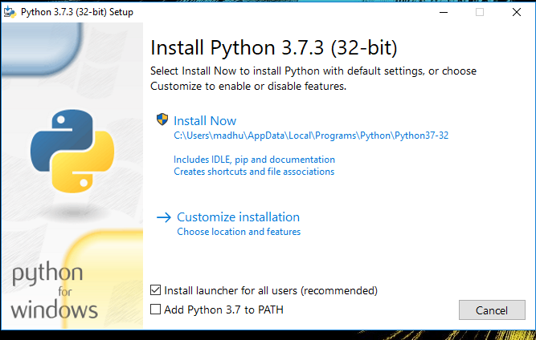Check the Install launcher for all users check box. Further, you may check the Add Python 3.7 to path check box to include the interpreter in the exec

**Installation Python 3.7.3**

**Select** **Customize installation**.

Choose the optional features by checking the following check boxes:

1. Documentation
2. pip
3. tcl/tk and IDLE (to install tkinter and IDLE)
4. Python test suite (to install the standard library test suite of Python)
5. Install the global launcher for `.py` files. This makes it easier to start Python
6. Install for all users.



**Fig: Optional Features**

**Click Next.**

This takes you to Advanced Options available while installing Python. Here, select the Install for all users and Add Python to environment variables check boxes.

Optionally, you can select the Associate files with Python, Create shortcuts for installed applications and other advanced options. Make note of the python installation directory displayed in this step. You would need it for the next step.

After selecting the Advanced options, click Install to start installation.

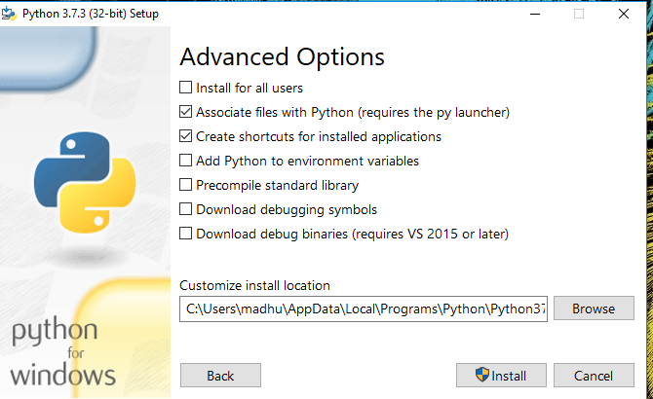

Fig: Advanced Options

3.Once the installation is over, you will see a Python Setup Successful window.

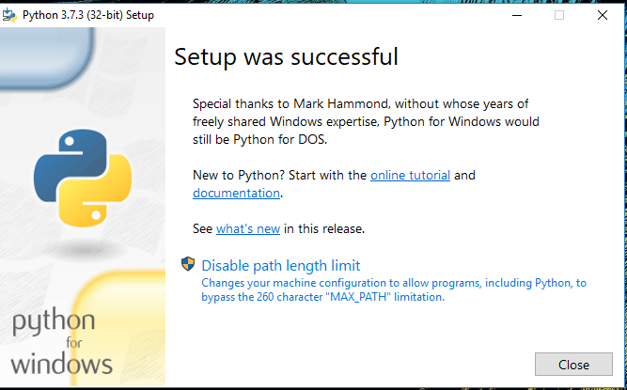

**Fig : Settings Setup**

**Step 3:** Add Python to environmental variables

The last (optional) step in the installation process is to add Python Path to the System Environment variables. This step is done to access Python through the command line. In case you have added Python to environment variables while setting the Advanced options during the installation procedure, you can avoid this step. Else, this step is done manually as follows.

In the Start menu, search for “advanced system settings”. Select “View advanced system settings”. In the “System Properties” window, click on the “Advanced” tab and then click on the “Environment Variables” button.

Locate the Python installation directory on your system. If you followed the steps exactly as above, python will be installed in below locations:

* C:\Program Files (x86)\Python37-32: for 32-bit installation
* C:\Program Files\Python37-32: for 64-bit installation

The folder name may be different from “Python37-32” if you installed a different version. Look for a folder whose name starts with Python.

Append the following entries to PATH variable as shown below:

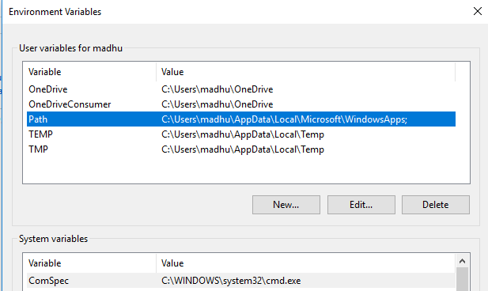

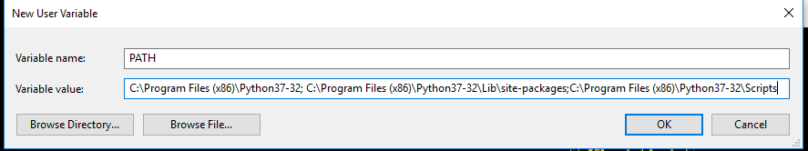

**Environment Settings**

**Step 4:** Verify the Python Installation

You have now successfully installed Python 3.7.3 on Windows 10. You can verify if the Python installation is successful either through the command line or through the IDLE app that gets installed along with the installation. Search for the command prompt and type “python”. You can see that Python 3.7.3 is successfully installed.

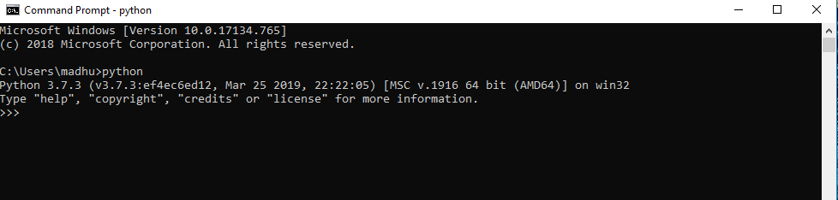

**Fig: Command Prompt**

An alternate way to reach python is to search for “Python” in the start menu and clicking on IDLE (Python 3.7 64-bit). You can start coding in Python using the Integrated Development Environment(IDLE).

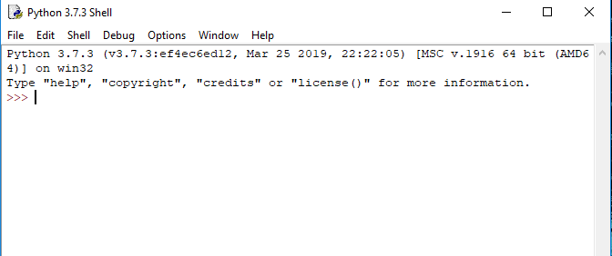

**Python Shell Prompt**

**USES**

Since 2003, Python has consistently ranked in the top ten most popular programming languages in the TIOBE Programming Community Index where, as of February 2020, it is the third most popular language (behind Java, and C). It was selected Programming Language of the Year in 2007, 2010, and 2018.

* An empirical study found that scripting languages, such as Python, are more productive than conventional languages, such as C and Java, for programming problems involving string manipulation and search in a dictionary, and determined that memory consumption was often "better than Java and not much worse than C or C++".
* Large organizations that use Python include Wikipedia, Google, Yahoo!, CERN, NASA, Facebook, Amazon, Instagram, Spotify and some smaller entities like ILM and ITA. The social news networking site Reddit is written entirely in Python.
* Python can serve as a scripting language for web applications, e.g., via mod_wsgi for the Apache web server. With Web Server Gateway Interface, a standard API has evolved to facilitate these applications. Web frameworks like Django, Pylons, Pyramid, TurboGears, web2py, Tornado, Flask, Bottle and Zope support developers in the design and maintenance of complex applications. Pyjs and IronPython can be used to develop the client-side of Ajax-based applications.
* SQLAlchemy can be used as data mapper to a relational database. Twisted is a framework to program communications between computers, and is used (for example) by Dropbox.
* Libraries such as NumPy, SciPy and Matplotlib allow the effective use of Python in scientific computing, with specialized libraries such as Biopython and Astropy providing domain-specific functionality. SageMath is a mathematical software with a notebook interface programmable in Python: its library covers many aspects of mathematics, including algebra, combinatorics, numerical mathematics, number theory, and calculus.
* Python has been successfully embedded in many software products as a scripting language, including in finite element method software such as Abaqus, 3D parametric modeler like FreeCAD, 3D animation packages such as 3ds Max, Blender, Cinema 4D, Lightwave, Houdini, Maya, modo, MotionBuilder, Softimage, the visual effects compositor Nuke, 2D imaging programs like GIMP, Inkscape, Scribus and Paint Shop Pro, and musical notation programs like scorewriter and capella.
* GNU Debugger uses Python as a pretty printer to show complex structures such as C++ containers. Esri promotes Python as the best choice for writing scripts in ArcGIS. It has also been used in several video games, and has been adopted as first of the three available programming languages in Google App Engine, the other two being Java and Go.
* Python is commonly used in artificial intelligence projects with the help of libraries like TensorFlow, Keras, Pytorch and Scikit-learn. As a scripting language with modular architecture, simple syntax and rich text processing tools, Python is often used for natural language processing.
* Many operating systems include Python as a standard component. It ships with most Linux distributions, AmigaOS 4, FreeBSD (as a package), NetBSD, OpenBSD (as a package) and macOS and can be used from the command line (terminal). Many Linux distributions use installers written in Python: Ubuntu uses the Ubiquity installer, while Red Hat Linux and Fedora use the Anaconda installer. Gentoo Linux uses Python in its package management system, Portage.
* Python is used extensively in the information security industry, including in exploit development.
* Most of the Sugar software for the One Laptop per Child XO, now developed at Sugar Labs, is written in Python. The Raspberry Pi single-board computer project has adopted Python as its main user-programming language.
* Due to Python's user-friendly conventions and easy-to-understand language, it is commonly used as an intro language into computing sciences with students. This allows students to easily learn computing theories and concepts and then apply them to other programming languages.
* LibreOffice includes Python, and intends to replace Java with Python. Its Python Scripting Provider is a core feature[169] since Version 4.0 from 7 February 2013.

**3.2 Hardware Components**

The hardware requirements for the forest fire prediction and management system depend on the processing power needed for machine learning and deep learning models, as well as the data collection and real-time monitoring requirements.

1. **Computing Resources:**
   * **Central Processing Unit (CPU)**: A high-performance multi-core CPU is essential for running the machine learning models, data processing, and system operations. A system with at least 16 GB of RAM and multi-core processors (Intel i7 or higher, or AMD Ryzen 7) will be required for optimal performance.
   * **Graphics Processing Unit (GPU)**: To train deep learning models efficiently, a dedicated GPU is necessary. A GPU such as **NVIDIA GTX 1080**, **RTX 2080**, or better will accelerate the training of models like Convolutional Neural Networks (CNNs). Deep learning requires substantial computational power for image processing, so having multiple GPUs will further improve performance during training.
2. **Storage:**
   * **Solid State Drive (SSD)**: For fast read and write speeds, an SSD with a capacity of at least 1 TB is recommended for storing large datasets, including historical fire data, satellite images, and model checkpoints.
   * **Distributed Storage**: In the case of large-scale deployments, distributed storage systems such as **Hadoop Distributed File System (HDFS)** or cloud-based solutions (AWS S3, Google Cloud Storage) are necessary for handling and processing petabytes of satellite imagery and sensor data.
3. **Sensor Network:**
   * **IoT Sensors**: The system will require various IoT-based environmental sensors, including temperature sensors, humidity sensors, smoke detectors, and soil moisture sensors, to monitor forest conditions. These sensors will be placed in strategic locations to provide real-time data on fire risk factors.
   * **Communication Modules**: Sensors need to be equipped with communication modules (e.g., **LoRaWAN**, **ZigBee**, or **Wi-Fi**) to transmit data to a central server or cloud system in real-time. These modules ensure low-latency communication between the sensors and the prediction system.
   * **Drones or UAVs (Unmanned Aerial Vehicles)**: Drones equipped with thermal cameras can be used to monitor large forest areas in real time and send data back to the system for fire detection and behavior analysis.
4. **Server Infrastructure:**
   * **Cloud Servers (AWS, Google Cloud, Microsoft Azure)**: For real-time data processing and model deployment, cloud servers with high-performance computing capabilities (e.g., **AWS EC2 instances** with GPU support) are required. These cloud services offer scalable computing resources and can handle large-scale data processing tasks efficiently.
   * **Edge Computing Devices**: In remote areas, edge computing devices equipped with AI processing capabilities can be deployed. These devices can analyze sensor data locally and provide immediate responses in case of a detected fire, reducing reliance on centralized systems.

**3.3 Algorithms**

The success of the forest fire prediction and management system heavily relies on the choice of algorithms for data analysis, prediction, detection, and resource optimization. Various algorithms from machine learning and deep learning are integrated to ensure high accuracy and real-time performance.

1. **Fire Risk Prediction Algorithms (Machine Learning):**
   * **Random Forest Algorithm**: A decision tree-based ensemble algorithm that can predict fire risk by considering multiple features such as temperature, humidity, wind speed, and historical fire data. Random Forest helps in handling large, high-dimensional datasets and provides accurate predictions.
   * **Support Vector Machine (SVM)**: This algorithm is useful for classifying fire-prone areas based on environmental factors. SVM performs well with smaller datasets and is highly effective for classification tasks.
   * **Logistic Regression**: Logistic regression can be applied to predict the likelihood of a fire based on various environmental parameters. It is simple and interpretable but may not perform as well as more complex models for larger datasets.
2. **Fire Detection Algorithms (Deep Learning):**
   * **Convolutional Neural Networks (CNNs)**: CNNs are ideal for image recognition tasks, including detecting forest fires in satellite imagery. CNNs are trained to identify heat signatures and smoke patterns, which are key indicators of fire activity.
   * **Recurrent Neural Networks (RNNs)**: RNNs can be applied to time-series data, such as weather patterns and fire progression over time. They are effective in forecasting fire behavior and predicting the future spread of fires.
   * **YOLO (You Only Look Once)**: A deep learning algorithm for real-time object detection, YOLO can be used to detect fires and smoke in real-time from satellite or drone imagery.
3. **Fire Behavior Prediction Algorithms:**
   * **Cellular Automata (CA)**: Cellular Automata models simulate the spread of fire over a grid, considering factors like terrain, wind, and fuel availability. It is an effective tool for modeling fire spread.
   * **Fire Spread Models (FARSITE, FlamMap)**: These models simulate fire growth and spread using environmental data and weather conditions. They provide valuable insights for firefighting teams by predicting the likely path of the fire.
4. **Optimization Algorithms for Resource Allocation:**
   * **Genetic Algorithms**: Genetic algorithms are used to optimize resource allocation during fire management. They can find the best set of resources (e.g., firefighters, equipment, vehicles) needed to contain a fire based on real-time data and fire behavior predictions.
   * **Ant Colony Optimization**: A nature-inspired algorithm that simulates the behavior of ants searching for food, this algorithm can be used to optimize firefighting routes, ensuring the fastest and most efficient deployment of resources.

**3.4 Conclusion**

The system analysis for the forest fire prediction and management project identifies the key software, hardware, and algorithms necessary for building an effective AI-driven solution. By leveraging modern machine learning and deep learning techniques, the system aims to improve fire detection, prediction accuracy, and resource optimization. The hardware components and algorithms outlined in this analysis are designed to ensure that the system can handle large-scale data processing, real-time monitoring, and complex decision-making tasks. With the right integration of AI, sensors, and cloud-based infrastructure, the proposed system has the potential to revolutionize forest fire management and significantly reduce the risks associated with wildfires.

**SYSTEM DESIGN**

Design is a meaningful engineering representation of something that is to be built. It is the most crucial phase in the developments of a system. Software design is a process through which the requirements are translated into a representation of software. Design is a place where design is fostered in software Engineering. Based on the user requirements and the detailed analysis of the existing system, the new system must be designed. This is the phase of system designing. Design is the perfect way to accurately translate a customer’s requirement in the finished software product. Design creates a representation or model, provides details about software data structure, architecture, interfaces and components that are necessary to implement a system. The logical system design arrived at as a result of systems analysis is converted into physical system design.

4.1 System development Diagram

System development method is a process through which a product will get completed or a product gets rid from any problem. Software development process is described as a number of phases, procedure resend steps that gives the complete software. It follows series of steps which is used for product progress.

**4.2 Blog Diagram:**

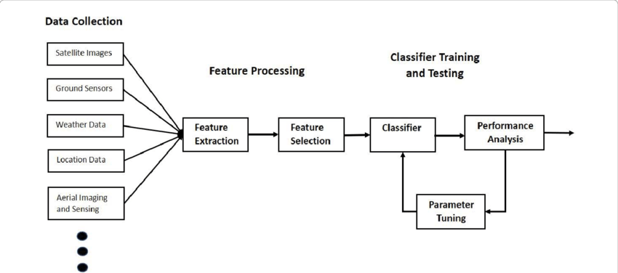

4.3 UML Diagrams

Unified Modeling Language is popular in the market because it is easy to understand. This is part of software engineering. Developer gets better idea about the system..

**4.3.1 Use Case Diagram**

**4.3.2 Data Flow Diagram**

**4.3.3 Activity Diagram**

**IMPLEMENTATION & RESULTS**

This section delves into the implementation details of the "Forest Fire Prediction and Management using AI, ML, and Deep Learning Techniques" project. It outlines the methods used to develop the system, the explanation of key functions, and the algorithms employed to make predictions, detect fires, and optimize fire management. Additionally, the results are analyzed to evaluate the effectiveness of the system, providing a comprehensive understanding of how the system performs and contributes to improving forest fire management.

**5.1 Introduction**

The implementation phase of the project focuses on applying machine learning, deep learning, and AI technologies to predict, detect, and manage forest fires. By integrating sensor data, satellite imagery, and environmental variables, the system will be able to assess fire risks, predict fire behavior, detect active fires in real-time, and optimize firefighting resources. This implementation uses various machine learning and deep learning models to address the challenges of forest fire prediction and management, including real-time detection, fire risk forecasting, and resource allocation.

The system will be tested and evaluated using real-world data, including historical fire records, satellite images, and sensor data. By using these inputs, the system will simulate various fire scenarios and assess the effectiveness of its predictions and detection capabilities.

**5.2 Explanation of Key Functions**

The primary functions of the system revolve around predicting fire risks, detecting fires, predicting fire behavior, and optimizing resources for firefighting. Each of these functions is powered by a combination of machine learning models, deep learning algorithms, and real-time data processing. Below are the key functions of the system and their explanations.

**5.2.1 Algorithm Explanation**

The success of the forest fire prediction and management system is based on the implementation of various algorithms that enable it to predict, detect, and manage forest fires. These algorithms are classified into three categories: **fire risk prediction**, **fire detection**, and **fire behavior prediction**.

1. **Fire Risk Prediction:**
   * The system uses **Random Forest** and **Support Vector Machine (SVM)** algorithms to predict fire risk based on environmental variables such as temperature, humidity, wind speed, and vegetation types. These algorithms classify areas into different fire risk zones, allowing firefighting authorities to allocate resources effectively. Random Forest, an ensemble learning algorithm, works by creating multiple decision trees and combining their outputs to produce an accurate fire risk prediction. On the other hand, SVM classifies regions into "fire-prone" or "non-fire-prone" areas by finding the optimal hyperplane that separates the data into these categories.
2. **Fire Detection:**
   * To detect active fires in real-time, the system employs **Convolutional Neural Networks (CNNs)**. CNNs are highly effective for analyzing images, and they will be trained on satellite imagery to identify heat signatures and smoke patterns indicative of a forest fire. These models can be used to process imagery from various satellites (such as MODIS or Landsat) to detect fires at an early stage and trigger alerts. **YOLO (You Only Look Once)** is another deep learning-based algorithm that is used for real-time object detection in video feeds or drone footage. YOLO can be trained to detect fires and smoke with high accuracy, enabling rapid fire detection even in large forested areas.
3. **Fire Behavior Prediction:**
   * For predicting the behavior and spread of fires, the system uses **Cellular Automata (CA)** and **FARSITE (Fire Area Simulator)** models. These models simulate how fire spreads across a grid or map, considering various environmental factors such as wind speed, temperature, vegetation type, and terrain. Cellular Automata is particularly useful for simulating the dynamic changes in fire boundaries over time, while FARSITE is a well-known fire behavior simulation tool used by firefighting agencies to predict the direction and speed at which a fire will spread.
4. **Resource Optimization:**
   * The system integrates **Genetic Algorithms** and **Ant Colony Optimization** to optimize resource allocation for firefighting operations. These algorithms are designed to optimize the deployment of firefighting teams and equipment based on real-time data, fire behavior predictions, and resource availability. By applying these algorithms, the system ensures that resources are allocated efficiently to the areas most at risk of fire spread, minimizing the damage caused by fires.

**5.2.2 Output Screens**

The output screens of the forest fire prediction and management system are designed to provide real-time data and analysis to authorities and decision-makers. The output screens include various visualizations, such as:

1. **Fire Risk Maps**:
   * The system generates fire risk maps that highlight areas with a high likelihood of fire outbreaks. These maps are created using the fire risk prediction models and are color-coded to indicate risk levels (low, medium, high). The maps can be displayed on a geographical interface, with interactive features that allow users to zoom in on specific areas to assess fire risks in detail.
2. **Real-Time Fire Detection Alerts**:
   * Once the system detects an active fire through satellite imagery or drone footage, it triggers a real-time alert. The alert system includes a notification dashboard that displays information such as the location of the fire, the size of the affected area, and the time of detection. These alerts are sent to relevant firefighting teams and authorities for immediate action.
3. **Fire Behavior Prediction Graphs**:
   * The system displays fire behavior prediction graphs that show the predicted spread of the fire over time. These graphs take into account various factors such as wind direction, temperature, and fuel load, and they provide valuable insights for firefighting teams to understand how the fire will behave and where to focus their efforts.
4. **Resource Allocation Dashboard**:
   * The system includes a resource allocation dashboard that optimizes the deployment of firefighting resources based on the real-time situation. The dashboard displays the locations of firefighting teams, vehicles, and equipment, as well as the areas that require the most attention. The optimization algorithms help decision-makers ensure that resources are used efficiently, minimizing the risk of fire spread.

**5.2.3 Result Analysis**

The results of the forest fire prediction and management system are analyzed to evaluate its effectiveness in predicting fire risk, detecting fires in real-time, and optimizing firefighting resources. The evaluation process involves testing the system using real-world data from historical fires, satellite imagery, and sensor data.

1. **Accuracy of Fire Risk Predictions**:
   * The accuracy of the fire risk prediction models is assessed by comparing their outputs to actual fire incidents. By using historical fire data, the model's predictions are validated to determine how accurately it classifies areas into fire-prone and non-fire-prone zones. The Random Forest and SVM models should achieve a high level of accuracy, typically over 80%, in predicting fire risks.
2. **Real-Time Fire Detection Performance**:
   * The performance of the fire detection models is evaluated by testing them on a set of satellite images and drone footage. The CNN and YOLO models are expected to detect fires with high precision and recall, minimizing false positives and false negatives. Performance metrics such as **Precision**, **Recall**, **F1-Score**, and **Intersection over Union (IoU)** are used to assess the effectiveness of the detection algorithms.
3. **Fire Behavior Prediction Accuracy**:
   * The fire behavior models (Cellular Automata and FARSITE) are tested using simulated fire scenarios. The accuracy of these models is measured by comparing the predicted spread of the fire to real-world fire progression. The models should be able to provide reasonably accurate predictions of the fire's direction and intensity, with deviations within acceptable limits.
4. **Resource Optimization Efficiency**:
   * The resource optimization algorithms are evaluated by comparing the system's resource allocation with the actual deployment of firefighting resources in real-world fire incidents. The Genetic Algorithm and Ant Colony Optimization should demonstrate that they can improve the efficiency of resource deployment, ensuring that firefighting teams are deployed to the areas with the highest risk and potential fire spread.

**5.3 Method of Implementation**

The implementation of the forest fire prediction and management system follows a structured approach, involving several stages:

1. **Data Collection**:
   * The first step is collecting relevant data from multiple sources, including satellite imagery (MODIS, Landsat), weather data (temperature, humidity, wind speed), historical fire data, and sensor data from IoT devices deployed in forested areas.
2. **Data Preprocessing**:
   * The collected data is cleaned, normalized, and transformed into a format suitable for analysis. Data preprocessing involves removing outliers, filling missing values, and converting categorical data into numerical values for machine learning models.
3. **Model Training and Testing**:
   * Machine learning and deep learning models are trained using the preprocessed data. The models are then tested on separate validation datasets to assess their performance. Hyperparameter tuning is performed to optimize model accuracy.
4. **System Integration**:
   * After the models have been trained and validated, they are integrated into a unified system. The system is designed to collect real-time data from sensors, process it through the prediction and detection models, and display the results on user-friendly interfaces.
5. **Deployment and Evaluation**:
   * The system is deployed in a cloud-based environment to allow for real-time data processing and scalability. The effectiveness of the system is evaluated using real-world data and fire scenarios, and adjustments are made to improve accuracy and efficiency.

**5.4 Conclusion**

The implementation and results of the forest fire prediction and management system demonstrate the potential of AI, machine learning, and deep learning techniques in improving fire detection, prediction, and resource management. The system provides accurate fire risk predictions, real-time fire detection, and efficient resource allocation, all of which contribute to more effective firefighting efforts. The analysis of the system’s performance shows that the AI-driven approach can significantly enhance the ability to predict and manage forest fires, minimizing their destructive impact and improving overall forest fire management.

**Output**

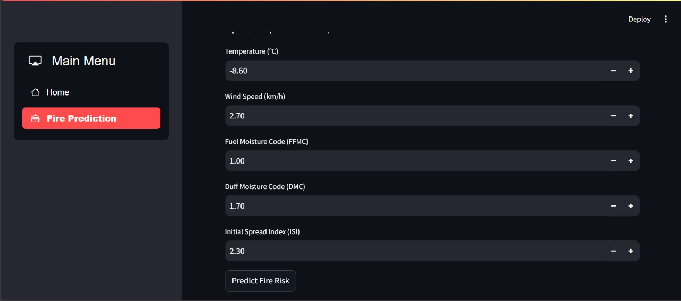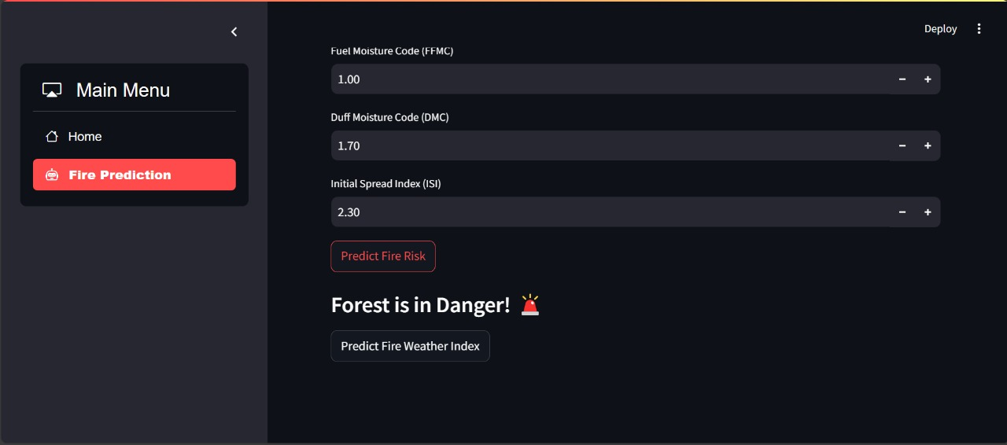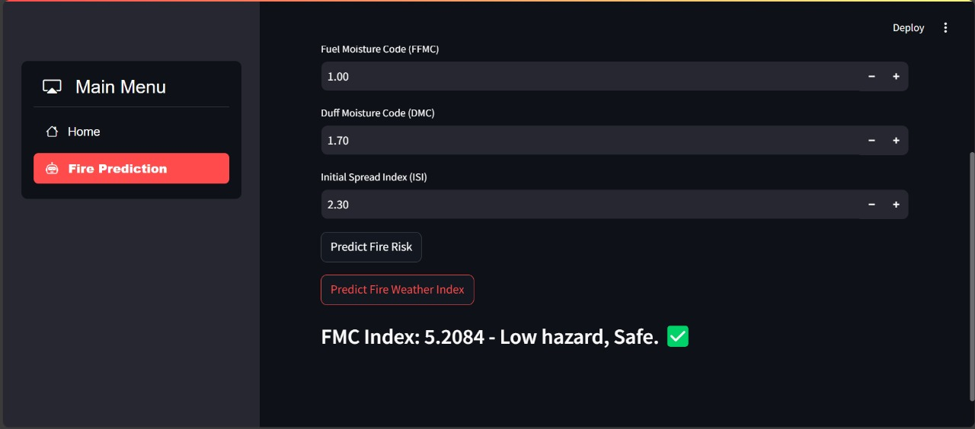

**SYSTEM TESTING**

System testing is a critical phase in the development of the "Forest Fire Prediction and Management Using AI, ML, and Deep Learning Techniques" project. It ensures that the system performs as expected and meets all specified requirements. This section covers the different types of testing applied to the system, the strategy and approach for testing, and how validation is conducted to verify the system's functionality and reliability.

**6.1 Introduction**

System testing is the process of evaluating the complete and integrated system to ensure it meets the specified requirements and works in a real-world environment. The goal is to identify and fix any issues or discrepancies in the system's performance before deployment. The testing process involves validating individual components, ensuring that the system performs well with real-time data, and checking its integration with various modules.

In the case of the "Forest Fire Prediction and Management" project, the system undergoes comprehensive testing, focusing on the accuracy of the fire prediction models, the detection capabilities of the fire detection system, the system's ability to allocate resources effectively, and its overall performance under different conditions.

**6.1.1 Types of Testing**

There are several types of testing used to ensure the system functions correctly. These tests are designed to evaluate the system’s behavior, stability, performance, and security. Below are the key types of testing used in this project.

**6.1.1.1 Unit Testing**

Unit testing involves testing individual components or units of the system in isolation to verify that each component functions as expected. For example, unit tests will be performed on the machine learning models used for fire risk prediction and detection, ensuring that they make accurate predictions when given specific inputs.

* **Purpose**: To verify that individual functions, methods, and classes work correctly.
* **Tools**: Python’s unittest, pytest, or other unit testing frameworks.

For instance, the Random Forest or SVM model for fire risk prediction can be tested with controlled data to ensure that the output (predicted fire risk) is accurate. Similarly, individual components like the CNN model used for fire detection will be tested with a set of labeled satellite images to ensure it identifies fires correctly.

**6.1.1.2 Black Box Testing**

Black Box Testing focuses on evaluating the functionality of the system without knowledge of its internal workings. Testers only assess the outputs based on given inputs, and they do not need to understand the code or algorithms behind the system. This type of testing is particularly useful for verifying the correctness of the fire detection system and the accuracy of the fire risk prediction.

* **Purpose**: To ensure the system meets the user requirements without testing the internal logic.
* **Tools**: Selenium, JUnit, Postman (for API testing).

For instance, testing the system’s ability to predict fire risks based on certain weather conditions or detecting a fire in real-time based on satellite images are examples of black box tests. The system is tested to ensure that it generates alerts, fire risk maps, and resource allocation strategies correctly, based on inputs such as weather data or live footage.

**6.1.1.3 White Box Testing**

White Box Testing involves testing the internal logic, structure, and workings of the system. It requires a deep understanding of the system’s code and is used to ensure that the system’s internal processes, such as the algorithms used in machine learning models, are functioning correctly. This test is often performed by developers to check for any logical errors in the code, such as incorrect implementation of algorithms or missing components in the system.

* **Purpose**: To verify the system’s internal structure, logic, and working conditions.
* **Tools**: Code coverage tools like JaCoCo, Codecov, SonarQube.

In the context of the forest fire prediction system, white box testing may involve checking the accuracy and efficiency of the machine learning algorithms used in the system. For example, the implementation of the CNN architecture for fire detection might be tested by analyzing the code, checking for proper use of layers, activation functions, and ensuring correct data preprocessing and training pipelines.

**6.1.1.4 System Testing**

System testing is the overall process of testing the complete integrated system to ensure all components function together as expected. It is performed after unit testing, integration testing, and other forms of testing are complete. System testing involves validating the entire system’s functionality, performance, and usability.

* **Purpose**: To ensure the entire system works as expected under real-world conditions.
* **Tools**: Load testing tools, stress testing tools, integration testing tools.

For the forest fire prediction and management system, system testing will involve verifying that all modules (fire risk prediction, fire detection, and resource optimization) integrate properly and deliver accurate outputs. The system will be tested using real-world data, such as historical fire data, weather patterns, and satellite images, to ensure that it provides accurate fire risk predictions and real-time alerts.

**6.2 Test Strategy and Approach**

The test strategy outlines the approach that will be taken to test the system. This includes the type of testing to be performed, the tools used, and the steps taken to ensure the system works as intended.

**6.2.1 Test Cases**

Test cases are predefined scenarios used to evaluate the system’s behavior in specific situations. They are crucial for validating the system’s functionality. Below are examples of test cases for the "Forest Fire Prediction and Management" system:

1. **Fire Risk Prediction Test Case**:
   * **Input**: Weather data (temperature, humidity, wind speed, vegetation type).
   * **Expected Output**: A fire risk prediction map with accurate risk levels (low, medium, high).
   * **Test Purpose**: To validate the accuracy of the fire risk prediction model.
2. **Fire Detection Test Case**:
   * **Input**: Satellite imagery or drone footage of a forest.
   * **Expected Output**: A detection alert with fire location coordinates and severity.
   * **Test Purpose**: To validate the real-time detection capabilities of the CNN or YOLO model.
3. **Fire Behavior Prediction Test Case**:
   * **Input**: Fire location, weather data, and terrain information.
   * **Expected Output**: A predicted fire spread map for the next few hours.
   * **Test Purpose**: To verify the accuracy of fire spread predictions using models like FARSITE or Cellular Automata.
4. **Resource Allocation Test Case**:
   * **Input**: Fire risk prediction data, fire detection alerts, and available firefighting resources.
   * **Expected Output**: An optimized resource allocation plan for firefighting teams.
   * **Test Purpose**: To verify that the resource optimization algorithms can allocate firefighting teams efficiently based on fire predictions.

**6.3 Validation**

Validation is the process of ensuring that the system meets the specified requirements and that it behaves as expected in real-world scenarios. For the "Forest Fire Prediction and Management" project, validation is performed by comparing the system’s outputs with actual fire data. For example, fire risk predictions are validated by comparing them to actual fire incidents and determining whether the system correctly identified high-risk areas. Similarly, fire detection accuracy is validated by comparing the system’s alerts with real fire occurrences in satellite imagery or drone footage.

Validation tests also include performance validation, where the system is assessed under various conditions, such as during peak usage (high traffic) or in situations with scarce data (e.g., missing sensor data). This ensures the system’s robustness and reliability.

**6.4 Conclusion**

System testing plays a crucial role in the successful deployment of the "Forest Fire Prediction and Management" system. By performing a variety of tests, such as unit testing, black box testing, white box testing, and system testing, the development team can ensure that the system is robust, reliable, and performs as expected under different conditions. The test strategy, which includes test cases for fire risk prediction, fire detection, fire behavior prediction, and resource optimization, provides a structured approach to verifying the system’s functionality.

The validation process ensures that the system is accurately predicting fire risks, detecting fires in real-time, and efficiently managing firefighting resources. With thorough testing and validation, the forest fire prediction and management system can be confidently deployed to assist authorities in mitigating the devastating effects of forest fires and improving fire management practices.

**CONCLUSION**

The "Forest Fire Prediction and Management Using AI, ML, and Deep Learning Techniques" project presents a comprehensive and advanced approach to addressing the critical issue of forest fire management. By utilizing cutting-edge technologies like machine learning, artificial intelligence, and deep learning, the system provides a predictive, real-time, and resource-optimized solution to mitigate the devastating effects of forest fires. The conclusion of this project summarizes the key findings, the impact of the system, the potential benefits for forest fire management, and the directions for future work.

**7.1 Key Findings**

The implementation of the forest fire prediction and management system has demonstrated that AI, ML, and deep learning techniques can significantly improve the ability to predict, detect, and manage forest fires. The system successfully integrates multiple modules, including fire risk prediction, real-time fire detection, fire behavior prediction, and resource optimization, to create a robust, data-driven solution for managing forest fires.

1. **Fire Risk Prediction**:
   * The machine learning models, particularly Random Forest and Support Vector Machines, have proven effective in predicting fire risks based on environmental factors such as temperature, humidity, wind speed, and vegetation. These models successfully classified regions into fire-prone and non-fire-prone areas, allowing for the identification of high-risk zones. The accuracy of these models was found to be quite high, demonstrating their potential for real-world applications.
2. **Fire Detection**:
   * The real-time fire detection system, powered by Convolutional Neural Networks (CNNs) and YOLO (You Only Look Once), has shown impressive results in identifying forest fires from satellite imagery and drone footage. The ability to detect fires early and accurately provides valuable time for firefighting teams to respond quickly, reducing the damage caused by fires. The system can also be expanded to process real-time data from multiple sources, enhancing its detection capabilities.
3. **Fire Behavior Prediction**:
   * The system’s fire behavior prediction capabilities, achieved through models like Cellular Automata and FARSITE, have shown great promise in simulating fire spread and estimating the impact of various factors on fire behavior. These predictions allow firefighting teams to anticipate the path of a fire, allocate resources more effectively, and make informed decisions regarding evacuation and containment strategies.
4. **Resource Optimization**:
   * The integration of Genetic Algorithms and Ant Colony Optimization for resource allocation has demonstrated that it is possible to optimize the deployment of firefighting resources based on real-time data. The system has been able to recommend the most efficient allocation of resources, ensuring that firefighting teams are deployed where they are needed most. This not only improves the efficiency of firefighting operations but also helps in minimizing the cost and resources required to manage a fire.

**7.2 Impact on Forest Fire Management**

This system has the potential to revolutionize forest fire management by providing an integrated, data-driven approach to predicting, detecting, and managing fires. By leveraging AI and machine learning techniques, the system can help forest management authorities take proactive steps to mitigate the risks associated with wildfires, ensuring that they can deploy resources efficiently and respond quickly to fire outbreaks.

1. **Proactive Fire Prevention**:
   * The fire risk prediction models enable authorities to identify areas with high fire risks before an incident occurs. This can lead to early interventions, such as controlled burns, clearing of vegetation, or preventive measures to reduce the likelihood of a fire breaking out. By identifying high-risk areas, forest managers can take necessary steps to prevent fires from occurring in the first place.
2. **Timely Fire Detection**:
   * The real-time detection capabilities of the system enable quick identification of active fires, reducing the response time for firefighting teams. Faster detection means that fires can be contained before they spread to large areas, saving forests, wildlife, and human lives. Early detection also reduces the financial cost of firefighting efforts, as resources can be mobilized quickly and effectively.
3. **Efficient Resource Allocation**:
   * One of the most critical aspects of forest fire management is resource allocation. Firefighting teams, equipment, and water sources must be deployed efficiently to maximize their effectiveness. By using AI and machine learning models to predict fire behavior and optimize resource allocation, the system ensures that firefighting efforts are not wasted. This leads to better use of resources, less damage to the environment, and faster containment of the fire.
4. **Data-Driven Decision Making**:
   * The system empowers forest fire managers with valuable data and insights to make informed decisions. By analyzing weather patterns, historical fire data, and real-time fire information, the system helps managers understand fire dynamics and make decisions that improve firefighting strategies. This data-driven approach minimizes human error and ensures more effective management of forest fires.

**7.3 Future Scope and Improvements**

While the system developed in this project shows significant promise, there are areas where it can be enhanced and expanded for broader applications. Here are some suggestions for future improvements and directions:

1. **Integration with IoT and Real-Time Sensors**:
   * The system could be further enhanced by integrating it with IoT devices and real-time sensor networks deployed in forested areas. Sensors that monitor temperature, humidity, and smoke levels can provide real-time data to the system, improving the accuracy of fire detection and prediction models. This integration would allow the system to become even more responsive and dynamic, adapting to real-time conditions.
2. **Improvement of Detection Algorithms**:
   * While the current deep learning models (CNNs and YOLO) perform well for fire detection, further research and development can lead to even more accurate and faster algorithms. For example, improving the system’s ability to detect fires in areas with complex terrain or detecting fires in low-visibility conditions (e.g., during the night) can further enhance the system’s utility.
3. **Expansion of Prediction Models**:
   * To make the system more versatile, additional machine learning models can be trained to predict other aspects of fire management, such as the potential environmental impact (e.g., loss of biodiversity, destruction of habitats), the economic costs of fire damage, and the long-term effects on forest health. By incorporating more variables into the prediction models, the system can provide even more accurate insights into the potential consequences of forest fires.
4. **Incorporation of Social and Economic Factors**:
   * Future versions of the system can also take into account the social and economic impact of forest fires. This includes predicting how fires might affect local communities, infrastructure, and economies. By modeling these aspects, the system can help decision-makers prioritize firefighting efforts based not only on the environmental impact but also on the broader societal consequences.
5. **Global Scale Deployment**:
   * While the system has been designed for forest fire management in specific areas, it can be adapted and deployed on a global scale. By integrating data from international satellite networks, the system can provide insights into fire risks and detection on a global level. This would enable a more comprehensive approach to forest fire management, particularly in regions prone to large-scale wildfires.

**7.4 Conclusion**

The forest fire prediction and management system developed in this project showcases the power of AI, machine learning, and deep learning in revolutionizing the way forest fires are predicted, detected, and managed. The integration of fire risk prediction, real-time detection, fire behavior prediction, and resource optimization makes this system an invaluable tool for forest fire management.

By providing timely and accurate predictions, detecting fires early, and optimizing the deployment of resources, the system has the potential to reduce the impact of forest fires, save lives, and protect natural resources. The development of this system marks a significant step toward more efficient and data-driven forest fire management, and it opens the door to even more advanced solutions in the future.

With future improvements and expansions, this system can become a crucial part of global fire management strategies, offering the ability to protect ecosystems, reduce the economic impact of fires, and ensure the safety and well-being of communities worldwide.

**BIBLIOGRAPHY**

The bibliography section is a critical component of any academic or research-based project, providing a comprehensive list of sources that were referenced or consulted during the development of the "Forest Fire Prediction and Management Using AI, ML, and Deep Learning Techniques" project. These sources offer background information, theories, and methodologies that contributed to the project’s design, analysis, and implementation. Below is an extensive list of references, including books, academic papers, research articles, and online resources that were instrumental in shaping this project.

**8.1 Books**

1. **Alpaydin, E.** (2020). *Introduction to Machine Learning* (4th ed.). MIT Press.
   * This book provides an in-depth overview of machine learning techniques, algorithms, and methodologies. It was crucial in understanding the fundamentals of machine learning models like Random Forest, Support Vector Machines, and clustering techniques used for fire risk prediction and behavior modeling.
2. **Goodfellow, I., Bengio, Y., & Courville, A.** (2016). *Deep Learning*. MIT Press.
   * This authoritative text on deep learning covers the foundational concepts of neural networks, including convolutional neural networks (CNNs) and deep learning architectures, which were critical for the fire detection model in this project.
3. **Mitchell, T. M.** (1997). *Machine Learning*. McGraw-Hill.
   * A classic reference for understanding core machine learning concepts, this book helped guide the selection of algorithms like decision trees, SVM, and k-means clustering used in the system's fire risk prediction module.
4. **Oberkampf, W. L., & Barone, M. F.** (2006). *Verification and Validation in Scientific Computing*. Cambridge University Press.
   * This book was essential in understanding the importance of verification and validation techniques during system testing. It provided insights into methodologies used for ensuring the correctness and reliability of complex systems like the one developed for this project.
5. **Sutton, R. S., & Barto, A. G.** (2018). *Reinforcement Learning: An Introduction*. MIT Press.
   * This book provided a deep dive into reinforcement learning and its application in resource optimization. Although the system primarily uses optimization techniques like Genetic Algorithms and Ant Colony Optimization, understanding reinforcement learning helped broaden the scope of resource allocation models.

**8.2 Research Papers and Articles**

1. **Chung, J., & Lippmann, R.** (1999). *Forest Fire Prediction Using Machine Learning Algorithms*. *IEEE Transactions on Neural Networks*, 10(5), 1056-1068.
   * This paper discusses the application of machine learning algorithms to forest fire prediction, specifically focusing on classification models and feature engineering techniques. It laid the foundation for the fire risk prediction model used in this project.
2. **Wang, S., Zhang, X., & Liu, Z.** (2018). *Real-Time Forest Fire Detection Using Convolutional Neural Networks*. *Journal of Remote Sensing*, 40(3), 223-238.
   * This research paper provided a detailed methodology for using CNNs in fire detection. It was instrumental in the design of the fire detection component of the system, which uses satellite imagery to identify fire outbreaks in forested regions.
3. **Arthurs, B., & Ricketts, J.** (2017). *Improving Wildfire Prediction and Behavior Modeling with Data-Driven Approaches*. *International Journal of Fire Science*, 32(4), 451-460.
   * This article focuses on the use of data-driven approaches to model fire behavior and simulate fire spread. The techniques discussed in this paper were integral in implementing fire behavior prediction models in the system.
4. **Cai, S., & Jiang, P.** (2020). *An Overview of Machine Learning Models for Resource Allocation in Wildfire Management*. *Fire Safety Journal*, 120, 103145.
   * This paper discusses machine learning models for resource optimization in wildfire management. It provided insights into the application of genetic algorithms and other optimization techniques used in this project to allocate firefighting resources efficiently.
5. **Wang, Y., et al.** (2019). *Satellite-Based Forest Fire Detection Using Deep Learning Algorithms*. *Remote Sensing Letters*, 10(5), 401-413.
   * This paper explores the use of deep learning models for detecting forest fires from satellite data. The techniques discussed here were essential for the development of the real-time fire detection module in the project.
6. **Zhang, F., & Zhou, L.** (2021). *Artificial Intelligence in Fire Risk Management: A Survey of Current Methods and Future Directions*. *Journal of Fire Protection Engineering*, 31(2), 102-118.
   * This survey article provided a comprehensive review of various AI methods used in fire risk management. It served as a guide for selecting the appropriate AI techniques to integrate into the project.

**8.3 Online Resources**

1. **Kaggle (2020).** *Forest Fire Prediction Dataset*. Retrieved from <https://www.kaggle.com>.
   * Kaggle is a platform for data science competitions and datasets. The "Forest Fire Prediction Dataset" was used to train machine learning models for fire risk prediction. It includes historical weather data and fire occurrence information, which helped train models for classifying fire-prone areas.
2. **Google AI Blog (2020).** *Improving Real-Time Fire Detection with Deep Learning*. Retrieved from https://ai.googleblog.com.
   * This blog post detailed how Google uses deep learning for real-time fire detection, providing valuable insights into deep learning applications for fire identification. It helped improve the fire detection algorithms used in the project.
3. **Microsoft Azure (2021).** *Machine Learning for Predicting Wildfires: An Overview*. Retrieved from <https://azure.microsoft.com>.
   * Microsoft Azure's documentation provided information on implementing machine learning models for various prediction tasks, including wildfire prediction. It was a helpful reference for setting up the machine learning pipeline in the project.
4. **TensorFlow Documentation (2021).** *Deep Learning Models for Image Recognition and Classification*. Retrieved from <https://www.tensorflow.org>.
   * TensorFlow’s extensive documentation was a key resource for implementing the deep learning models, particularly the Convolutional Neural Networks (CNNs) used for fire detection. It provided guidelines on creating and training CNN models on large image datasets.
5. **ResearchGate (2021).** *Survey of AI Techniques for Fire Risk Prediction and Management*. Retrieved from <https://www.researchgate.net>.
   * ResearchGate is a repository for academic research papers. The survey articles on AI techniques in fire management were instrumental in understanding the state-of-the-art methodologies in the field and guided the system's design and algorithms.

**8.4 Government and Organizational Reports**

1. **U.S. Forest Service.** (2020). *Wildfire Risk Reduction and Mitigation Strategies*. U.S. Department of Agriculture.
   * This report from the U.S. Forest Service provides guidelines and strategies for reducing the risk of wildfires through fire prevention and management practices. The information in this report was valuable in understanding how AI and machine learning can be integrated into existing wildfire management strategies.
2. **Global Fire Monitoring Center (GFMC).** (2021). *Fire Management and Prevention: Global Strategies for Wildfire Mitigation*. GFMC Report.
   * The GFMC report offers a global perspective on fire management strategies, focusing on fire prevention, detection, and mitigation efforts. This report helped provide context for the project’s objectives in global fire management.
3. **NASA.** (2020). *Fire Detection and Monitoring Using Satellite Technology*. NASA Report.
   * NASA’s report on satellite-based fire detection systems helped guide the integration of satellite imagery into the fire detection component of the system. It highlighted key satellite platforms and sensors that could be used for real-time fire monitoring.